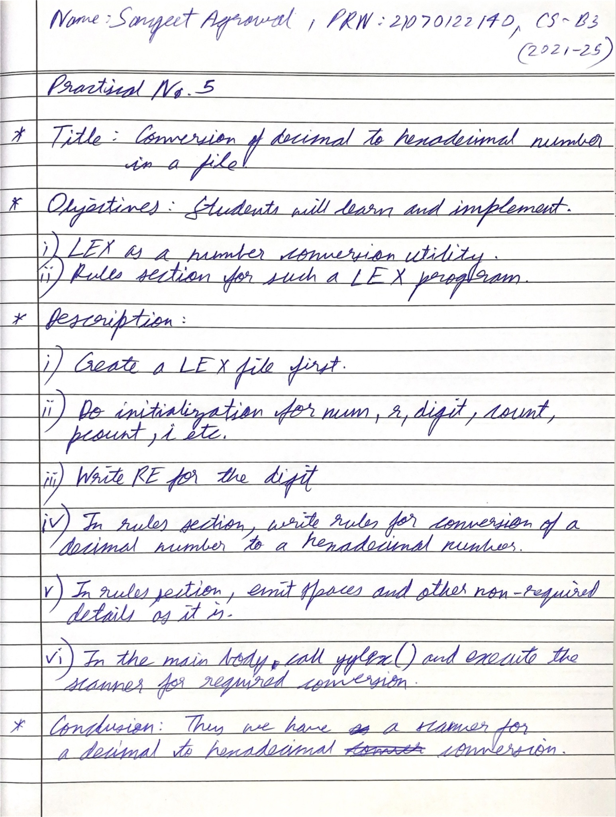

Code:

| %{ #include <stdio.h> #include <stdlib.h>  void decimal_to_hexadecimal(int decimal, char *hex) {  sprintf(hex, "%X", decimal); } %}  DIGIT [0-9] DECIMAL {DIGIT}+ WORD [A-Za-z]+  %%  {DECIMAL} {  int decimal = atoi(yytext);  char hex[10];  decimal_to_hexadecimal(decimal, hex);  printf("%s", hex); // Print the hexadecimal number }  {WORD} {  printf("%s", yytext); // Print the word (text) }  [ \t\n]+ {  // Handle whitespace by printing it as is  printf("%s", yytext); }  . {  // Print any other single characters  printf("%s", yytext); }  %%  int main() {  yylex();  return 0; } |
| --- |

Output:

